An evolutionary approach for finding optimal trees in undirected networks
David K. Smith, Godfrey A. Walters
European Journal of Operational Research, Volume:120, Issue: 3, February 1, 2000, pp. 593-602
Abstract
For efficiency, many such distribution networks are constructed as trees.This paper presents a method for identifying a tree which is close to optimal.This evolutionary method is based on ideas from genetic algrithms.
- Introduction
- Reproduction rules for trees
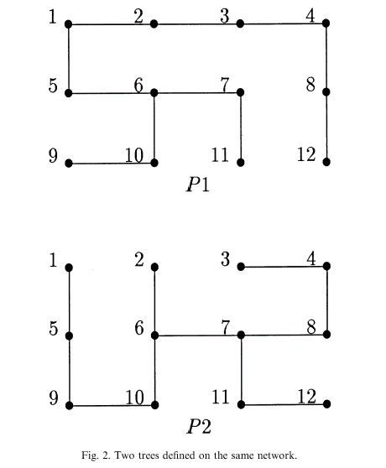
The Common edges are {(1, 5), (3, 4), (4, 8), (6, 7), (6, 10), (7, 11), (9, 10)}
The specific edges in P1 and P2 respectively are {(1, 2), (2, 3), (5, 6), (8, 12)} and {(2, 6), (5, 9), (7, 8), (11, 12)}

An simple example to reduce the probability of generating offspring that are not trees.
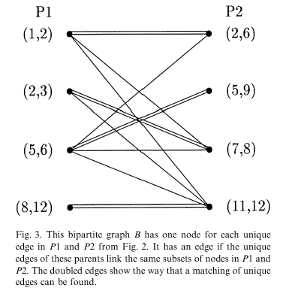
- An evolutionary optimization strategy
Step 1: Generate an initial pool S₀ of M trees T₁, .., T_{M} at random. Permute the set E into a random order.
Step 2: Caculate f_{j} = f (T_{j}) for j = 1,…M and identify the best tree T_{k}’.
Step 3: Select two distinct trees P1, P2, from S_{k} at random, using the fitness measure to ensure that the “fitter” trees have a greater chance of being selected.Identify the set of edges (C) which are common to both trees and the two sets of edges(U1, U2) which are unique to them. Calculate m = |U1|. If m <=1 then do Step 6.
Step 4: Create a bipartite graph B with 2m vertices. Find a maximum cardinality matching in B using a network or assignment model, and associate each edge e⁽¹⁾ in U1 with a corresponding edge e⁽²⁾ in U2.
Step 5: Create potential offspring C1, C2 as follows. Initially C1 = C2 = C.If m >= 4, test whether they are trees. If they are both trees, add them to the current pool of offspring S_{k+1} and if this pool is incomplete. Go to Step 3, otherwise go to Step 7. If C1 or C2 or both are not trees then repeat Step 5.
Step 6: Create offspring C1, C2 which are identical to their parents, and add these to the pool S_{k+1} and if this pool is incomplete, go to Step 3, otherwise go to Step 7
Step 7: Randomly mutate a fraction of the next generation S_{k+1} by choosing one edge at random and replacing that edge by another (if one exists) that will give a tree. Replace a randomly selected member of S_{k+1} by the best tree found, T_{k}’. k++. If k <= N, go to Step 2, otherwise stop, with T_{k}’ as the best tree.
- Results
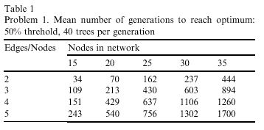
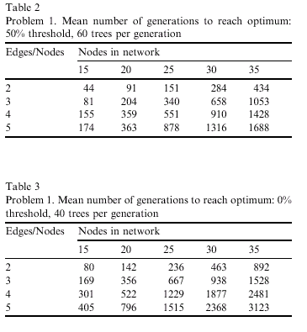
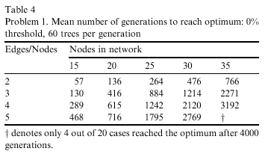
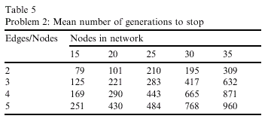
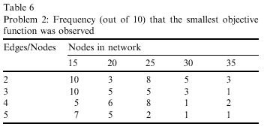
Created by: Ming-Cheng Lin
Date: Aug. 24, 2000

